PRACTICAL-7 LINKED LIST
Aim:- 1. Write a program to insert a new node into the linked list. A node can be added into the linked list using three ways: [Write code for all the three ways.]
a. At the front of the list
b. After a given node
c. At the end of the list.
2. Write a program to delete a node from the linked list. A node can be deleted from the linked list using three ways: [Write code for all the three ways.]
a. Delete from the beginning
b. Delete from the end
c. Delete from the middle.
Theory:- In this program we have implanted linked list and the creation of new node along with destruction of a node.
In insertion in front we first assign start to new node’s link and update start to new node. In between after a given node if 0 is there then it is insert at front if it is anything else then we find the loc of prev node. We then update the link in new node to the link of prev node and then update prev node link to new node. In insert at end we traverse through the linked list and when we encounter null we update that node’s link to new node.
In deletion in front we give temp the start node then update start to that nodes link then free temp. In delete at between we get a position. If it is 1 then delete at front or else we get the pos of the prev node of that node then we first get temp to that node then update prev node’s link to this node’s link then free temp. In delete at end we find traverse till null is reached then we take temp as this node and then update prev node to null and free temp.
In display we traverse and print the linked list.
Code:-
#include<stdio.h>
#include<stdlib.h>
struct Node
{
int info;
struct Node *link;
};
struct Node *start=NULL;
struct Node *createNode(int item)
{
struct Node *new_node=(struct Node *)malloc(sizeof(struct Node));
if (new_node==NULL)
{
printf("Memory allocation failed\n");
return;
}
new_node->info=item;
new_node->link=NULL;
return new_node;
}
struct Node *loc(int pos)
{
struct Node *ploc=start;
for (int i=2;i<=pos;i++)
if (ploc!=NULL)
ploc=ploc->link;
else
break;
return ploc;
}
void insertAtFront(int item)
{
struct Node *new_node=createNode(item);
new_node->link=start;
start=new_node;
printf("\nElement %d entered\n",item);
}
void insertAtBetween(int pos,int item)
{
if (pos<0)
{
printf("Invalid Location of Node");
return;
}
else if (pos==0)
{
insertAtFront(item);
return;
}
struct Node *ploc=loc(pos);
if (ploc==NULL)
{
printf("Position out of range");
return;
}
struct Node *new_node=(struct Node *)malloc(sizeof(struct Node));
new_node->info=item;
new_node->link=ploc->link;
ploc->link=new_node;
printf("\nElement %d entered\n",item);
}
void insertAtEnd(int item)
{
struct Node *new_node=createNode(item);
if (start==NULL)
{
start=new_node;
}
else
{
struct Node *ptr=start;
while (ptr->link!=NULL)
ptr=ptr->link;
ptr->link=new_node;
}
printf("\nElement %d entered\n",item);
}
void deleteAtFront()
{
if (start==NULL)
{
printf("\nList is Empty\n");
return;
}
struct Node *temp=start;
printf("\nElement %d deleted\n",temp->info);
start=start->link;
free(temp);
}
void deleteAtPos(int pos)
{
if (pos<=0)
{
printf("Invalid Location of Node");
return;
}
else if (pos==1)
{
deleteAtFront();
return;
}
struct Node *ploc=loc(pos-1);
if (ploc==NULL)
{
printf("\nPosition out of range\n");
return;
}
struct Node *temp=ploc->link;
printf("\nElement %d deleted\n",temp->info);
ploc->link=temp->link;
free(temp);
}
void deleteAtEnd()
{
struct Node *temp=start;
while (temp->link->link!=NULL)
temp=temp->link;
printf("\nElement %d deleted\n",temp->link->info);
free(temp->link);
temp->link=NULL;
}
void printll()
{
struct Node *ptr=start;
printf("\n");
while (ptr!=NULL)
{
printf("%d -> ",ptr->info);
ptr=ptr->link;
}
printf("NULL\n");
}
int main()
{
int wc=1,choice,item,pos;
while(wc)
{
printf("\n1.Insert at the Front\n");
printf("2.Insert after a given Node\n");
printf("3.Insert at the End\n");
printf("4.Delete from the Front\n");
printf("5.Delete from the position\n");
printf("6.Delete from the End\n");
printf("7.Display Linked List\n");
printf("8.Exit\n");
printf("Choice from above:-");
scanf("%d",&choice);
switch(choice)
{
case 1:
printf("\nEnter element to enter:-");
scanf("%d",&item);
insertAtFront(item);
break;
case 2:
printf("\nEnter element to enter:-");
scanf("%d",&item);
printf("\nEnter position after which to enter:-");
scanf("%d",&pos);
insertAtBetween(pos,item);
break;
case 3:
printf("\nEnter element to enter:-");\
scanf("%d",&item);
insertAtEnd(item);
break;
case 4:
deleteAtFront();
break;
case 5:
printf("\nEnter position:-");
scanf("%d",&pos);
deleteAtPos(pos);
break;
case 6:
deleteAtEnd();
break;
case 7:
printll();
break;
case 8:
wc=0;
break;
default:
printf("\nEnter valid choice\n");
}
}
return 0;
}
Output:-
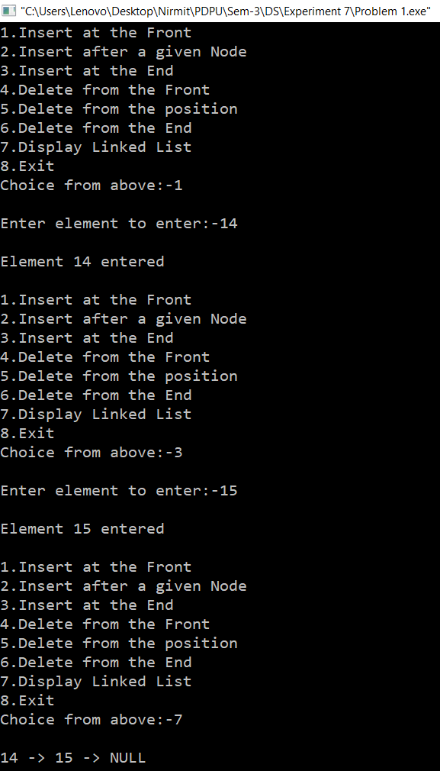
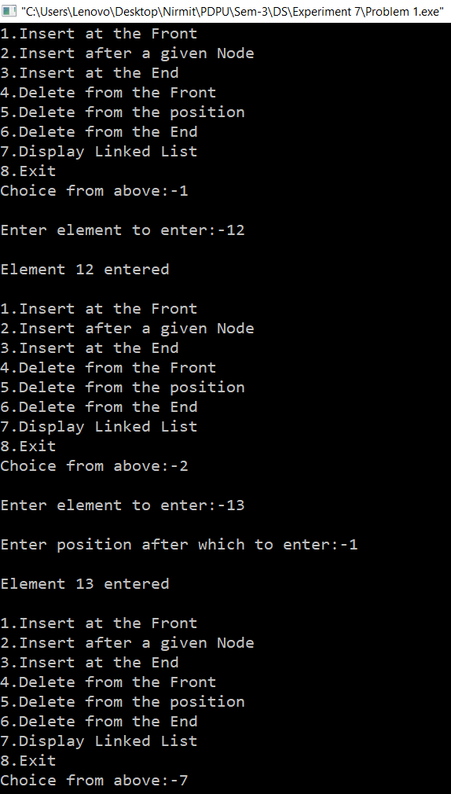
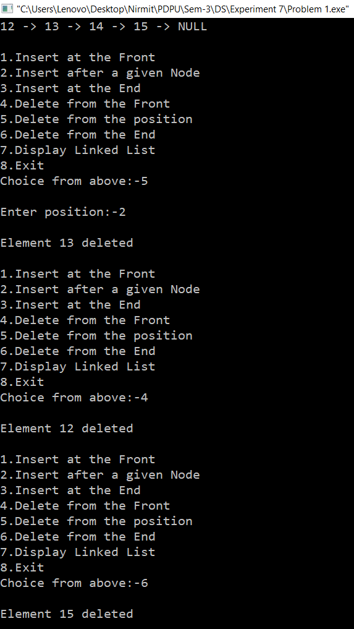
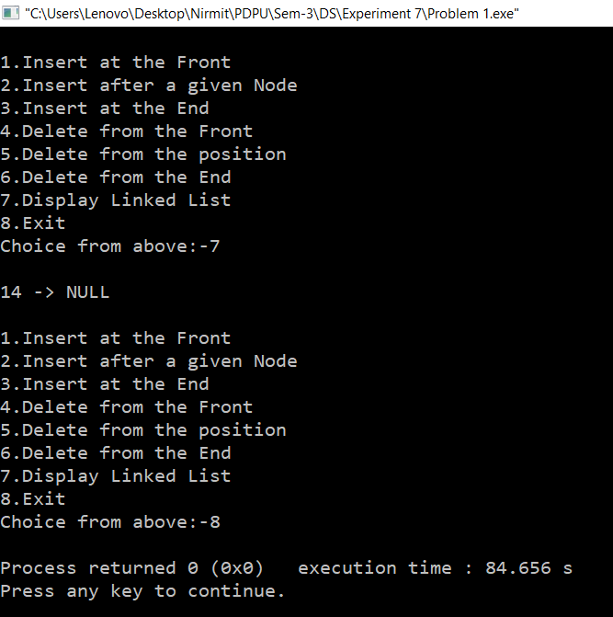
Time Complexity:- All insertions/deletions in between and end is O(n) while operations at front and display choice check take O(1). Overall O(n.k) where k is the operations performed.
Space Complexity:- The linked list stores n nodes, so O(n).

